Application:

**Program Design/Specification:**

The program is comprised of 4 main files. The first two 2 files are Json class files that specify the structure of two different API calls (forecast and current weather). The remaining two files are a run file for the Winform application, and the other is the implementation file of the API calls and the displaying of the Json data.

Breaking down the implementation file, you have 5 main methods. The first method is Form1_Shown, this method run once the main application window is shown. When shown, the method will prompt another window to ask for the location of where you want to get the weather. If the input is not valid, another prompt will show up again with an error message. If the the user wishes to exit the application, they clear the field and click enter. Once a valid location is entered, when call the second method, getCurrentWeatherJson, gets the current weather Json data. After the data is retrieved, the data will be sent to the updateCurrentWeather and the data will be parsed out of the Json and added to the Winform. A similar process is repeated for the last two methods,updateFiveDay and getFiveDayJson, but it retrieves the Json for the 5 day forecast of the location given. If any errors happen during this process, it will prompt to enter the location again.

**Overall Structure**

The structure of this assignment is made up of two primary groups, a client and a server. The server is the Open Weather API and the client is the application that is taking in the Json and parsing it.

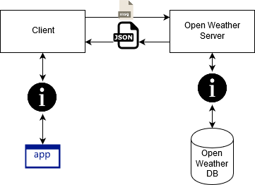

**Usage**

For compiling and running the program, please see the readme.txt file included.

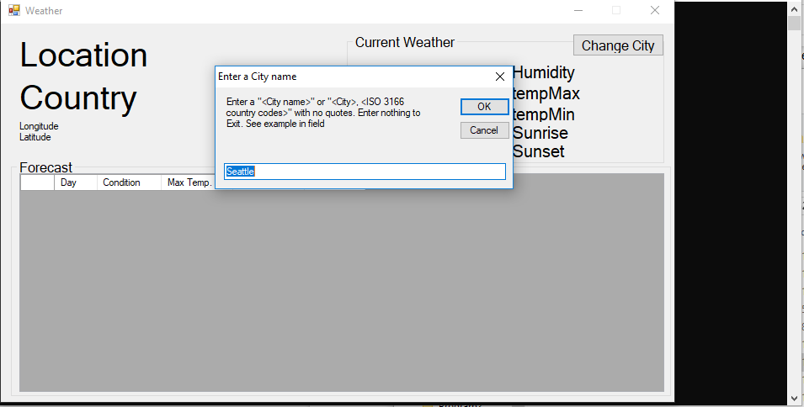

On launch of the application, you will be greeted with the application and a pop up window to enter a location. The location can be just a CIty or a City and a Country code (ISO 3166) separated by a comma. Examples “Athens” or “Athens, GR”. Upon entering the location the application will populate and you can view the data. If you want to change the location. Click the Change City button on the top right. If you want to quit, click the X in the top right. 